Resistance management guideline for controlling R81T target site resistant Myzus persicae populations, IRAC SPWG, 2019
This is an update of the resistance alert and management recommendations issued in January 2013 by the IRAC Sucking Pest Working Group. The resistance is based on a target-site mutation which strongly affects neonicotinoid efficacy^{1,2}. The results of surveys from 2010 to 2013 confirmed the spread and presence of the resistant aphids in many of the stone fruit orchards of Southern France, Spain and Italy ^{3,4}. Recent findings proved the resistance also in Greece, Morocco and Tunisia in stone fruit orchards and it was found even in Belgium in greenhouse vegetables. In the last few years the resistant strains were found in several greenhouse and open field vegetable plantations across Southern Europe.
Map of the region showing areas (yellow) where R81T target site resistance was detected in Myzus persicae collected from stone fruit orchards or vegetable crops between 2010 and 2018
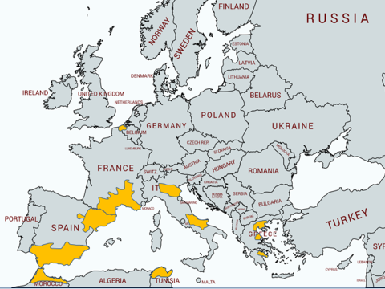

IRAC have worked with local agricultural ministry officials, and entomological experts from Spain, France, Italy and the UK, to provide the following advice for the impacted producers:
Where no loss of performance to Group 4 insecticides has been experienced in the field, it is recommended to use a maximum of one IRAC Group 4 insecticide application per crop cycle against Myzus persicae to minimize the further spread and intensification of the resistance and maintain effectiveness of those products in the impacted countries. Depending on crop and country and local guidelines, this single spray may be pre-flowering or post-flowering, but not during flowering, to fit with local IPM recommendations (Note: the restrictions to the imidacloprid, thiamethoxam and clothianidin announced in 2018 by the European Commission, the recommended rotation programme has been modified accordingly to comply with these restrictions. See attached rotation scheme).
If a decline in performance to Group 4 insecticides efficacy against Myzus persicae was observed during the previous seasons, it is recommended not to use this group of insecticides to prevent escalation or development of resistance. It is recommended to use effective insecticides with other modes of action, according to local registrations, such as products from groups 1, 3, 9, 23, 28 and 29⁵ as well as mineral oil to control Myzus persicae⁶. IRAC supports also the use of any other IPM measures locally recommended. When the other mode of action insecticide is chosen, the resistance status of the specific Myzus persicae population should be considered to avoid using insecticides, which are also resisted by the aphids. The best practical indicator is the historical performance of those insecticides in the specific region.
Acknowledgements: Many thanks to representatives of Rothamsted Research International, Università Cattolica del Sacro Cuore - Piacenza campus, Italy, University of Cartagena, Spain, Chamber of Agriculture in Catalunya and Aragon in Spain and the IRAC Spain Sucking Pest Working Group for inputs into these IRM recommendations.
¹ Bass et al. BMC Neuroscience 2011, 12:51 Mutation of a nicotinic acetylcholine receptor beta subunit is associated with resistance to neonicotinoid insecticides in the aphid Myzus persicae
² Puinean et al Pest Manag Sci (2012), Society of Chemical Industry, Development of a high-throughput real-time PCR assay for the detection of the R81T mutation in the nicotinic acetylcholine receptor of neonicotinoid-resistant Myzus persicae.
³ Slater et al, Pest Manag Sci 2012; 68: 634–638, Society of Chemical Industry, Identifying the presence of neonicotinoid resistant peach-potato aphid (Myzus persicae) in the peach-growing regions of southern France and northern Spain
⁴ Panini et al, Pest Manag Sci (2013), Society of Chemical Industry, Detecting the presence of target-site resistance to neonicotinoids and pyrethroids in Italian populations of Myzus persicae
⁵ See IRAC guidelines on Myzus persicae resistance management on the IRAC website
⁶ Consult local advisors for advice on which aphicides are affected by resistance in your locality.
Example of an IRM-based Program in Stone Fruits in Southern Europe to Limit Spread of R81T Target Site Resistance in Myzus persicae:

